Western National Rangeland Career Development Event
Contest Set Up
Prior to contest
- Write stocking rate scenario
- Choose current rangeland issue, write multiple choice questions, write current rangeland issue scenario.
- Print scorecards
- Select site (and a potential alternative). Site should be accessible by school bus and have appropriate parking and turn around area (Buses can drop students at locations, but must be able to turn around). Also consider all parts of the contest (e.g., need diversity of plants for Plant ID, adequate desirable forage, adequate brush (especially sagebrush).
- Get climate data before the day of the event; will need average annual precipitation for Part 3.
- Ask land managers to give overview of site at the beginning of event (Ranchers or BLM managers)
- Items needed for the field: Walkie Talkies, accordion files or large envelopes for score sheets, staplers, and rubber bands to keep score sheets on clipboards for students (and plastic bags if raining)
- Each of the 4 “Sections” of the contest that take place in the field (Part 2-5) are essentially stand-alone stations and should be set up accordingly using a clockwise rotation to ensure easy movement of students among stations.
- Placards should be placed in plastic sleeves and sleeves can be written on with a dry erase marker.
- Assign agency reps/volunteers to specific parts of the contest well in advance so they have adequate time to orient themselves prior to the day of the event. A brief volunteer training should take place in the field prior to the arrival of students.
- A walk-through of the actual contest must be conducted prior to commencement of the contest with instructors of the top 3 teams from the year prior.

Part 1—Stocking Rate and Management/Current Rangeland Issue
An event organizer will hand out the scorecards with a specific management scenario problems. The participants will work on the problem individually. Suggestion: do Part 1 in the classroom prior to going to the field. Supplies: Calculators and pencils (optional)

Part 2 – Plant Identification
Supplies:
- Placard for Part 2: Plant Identification
- Landscape flags (all one color) numbered 1-15
- 1 step in electric fence post to hold placard
- Plant mounts, potted plants (optional)
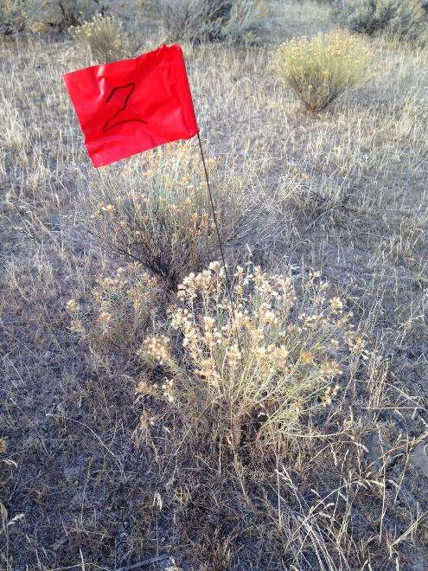
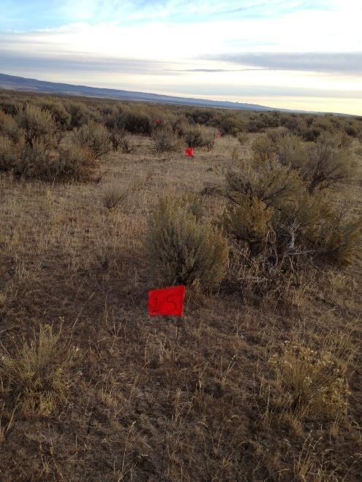
Flag 15 different species for identification. Each specimen will be clearly numbered and could be a dried and mounted specimen, potted plant, plastic plant, or flagged plant growing on the site. Remove all surrounding vegetation for 8-12 inches away from flagged plant.

Part 3: Site Description
Supplies:
- Placard for Part 3: Site Description and Part 3: Biomass Estimate
- 4 step-in electric fence posts, 2 for slope and aspect designation, 2 for placard
- 100 ft tape to measure (does not stay)
- Flagging tape (tie to the tops of 2 posts for slope and aspect, especially important in heavy brush)
- 3 water bottles (empty dish or syrup bottles are great)
- Paper towels for cleaning hands afterward
- Garbage bag to collect dirty paper towels
- Soil spade or shovel
- Yard Stick
- Clinometers
- Compasses
- 5 gallon bucket for topsoil
- 3, 4.8 ft² hoop (available from NRCS or make it)
- Clippers
- Bags
- Scales (digital or pen)

Participants will view the evaluation area and determine the precipitation zone, soil depth and rockiness, soil texture, soil salinity, slope, aspect, and biomass estimates. Along one side of the evaluation area, dig a soil pit at least 20 inches (64 cm) deep or to a restrictive layer if present (if less than 20 inches deep).

- Precipitation Zone: The average annual precipitation for the contest site will be provided on a placard located in the evaluation area.
- Soil Texture: Need to have some water set up next to the soil pit for students to complete the “Soil Texture by Feel Analysis” in the field. Topsoil will placed in a bucket to avoid ambiguity about the texture. Also have paper towels and a garbage bag for cleaning hands.
- Slope & Aspect: Lay out step-in electric fence posts (with flagging tape tied on top) that are spaced 100 feet apart (Tape does not stay). Participants will be required to estimate slope between the two endpoints using a clinometer provided. Aspect will be determined along the same transect as slope with a provided compass.
- Biomass Estimate: Use three, 4.8 ft² hoop (available from NRCS) or 2.2 ft x 2.2 ft frame to designate where participants will estimate annual production biomass (herbaceous AND current year’s growth on shrubs). When all participants have completed the event, the plots will be clipped by an event organizer and separated into herbaceous and woody shrub components in the field. Percent dry matter will be estimated based on published guidelines. 4.8 ft² = 93.2 inch circumference, multiply by 20 to covert grams of biomass to pounds per acre.

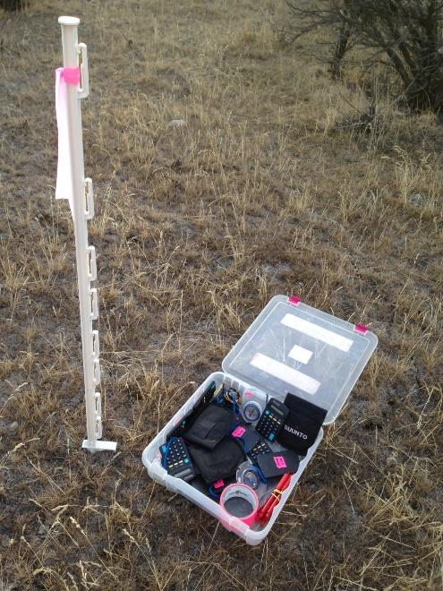
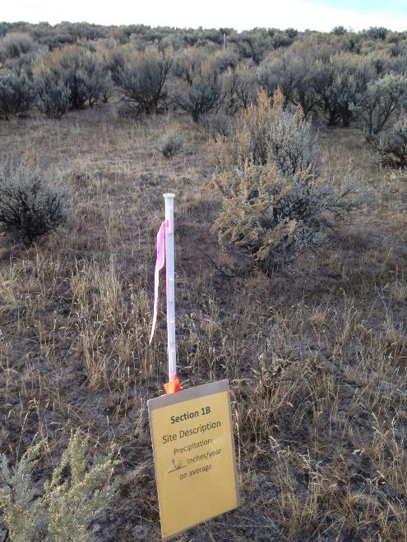
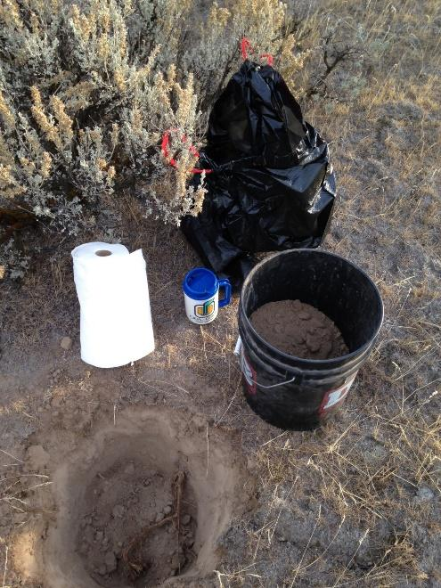
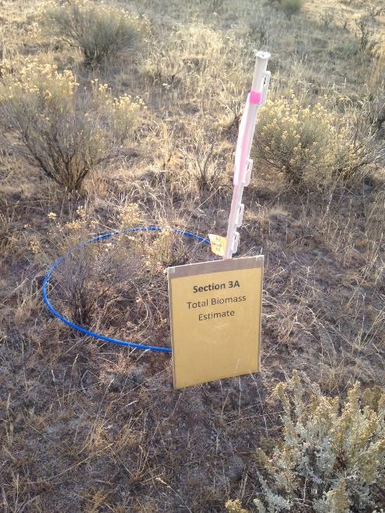

Part 4 – Rangeland Assessment
Supplies:
- Placard Part 4A: Similarity to Desired State, and Part 4B: Identify phase in simplified State and Transition Model
- 4 step-in electric fence posts (4 for Part 4A and Part 4B- marking reference area)
- 1, brightly colored stringlines (one ~25 m and one ~30 m long)
- 3 landscape flags all the same color labeled: Plot 1, Plot 2, Plot 3
- 3, 50 cm x 50 cm quadrat frames
- Ecological Site Description (ESD) of site for Part 4B (used to determine desired state)
- State and Transition Model for site (may be available on ESD).

Part 4A: Similarity to Desired State
Mark off a reference area roughly 15 x 30 ft that is largely representative of the general area with 4 step-in electric fence posts and brightly colored stringline. At this location, participants will estimate the current plant community. Within the reference area, place 3 square plot or quadrat frames (50x50 cm) marked with numbered flags (Plots 1-3) where participants will estimate proportions of biomass in each frame. The values for the desired state will be written on the placard posted at this rotation.

Part 4B: Identify phase in simplified State and Transition Model
Using vegetation in the reference area (5x5 m) from Part 4A, participants will identify the phase in a simplified State and Transition Model that is available as individual copies or as one copy displayed to all participants.

Part 5 – Rangeland Ecosystem Measurements
Supplies:
- Placard Part 5A: Height-Weight Utilization Estimate and Part 5B: Shrub Cover Estimates (including transect length)
- 4 step-in electric fence posts (1 for Part 5A and 3 for Part 5B)
- 20 landscape flags (all same color) numbered 1-20 for 5A
- 10 yardsticks for student use
- 10-20 Utilization gauges for student use
- Clippers (to create utilization if site is not utilized)
- 50 m measuring tape for 5B
- 2 pins to hold tape for 5B

Part 5A: Height-Weight Method Utilization
Participants will estimate forage utilization using the Height Weight method which uses the measured height of grazed and ungrazed grasses to determine percent utilization. 20 plants will be flagged, 5 of which should be ungrazed. The placard will identify the plant(s) being measured by common and scientific name to allow usage of the gauge.
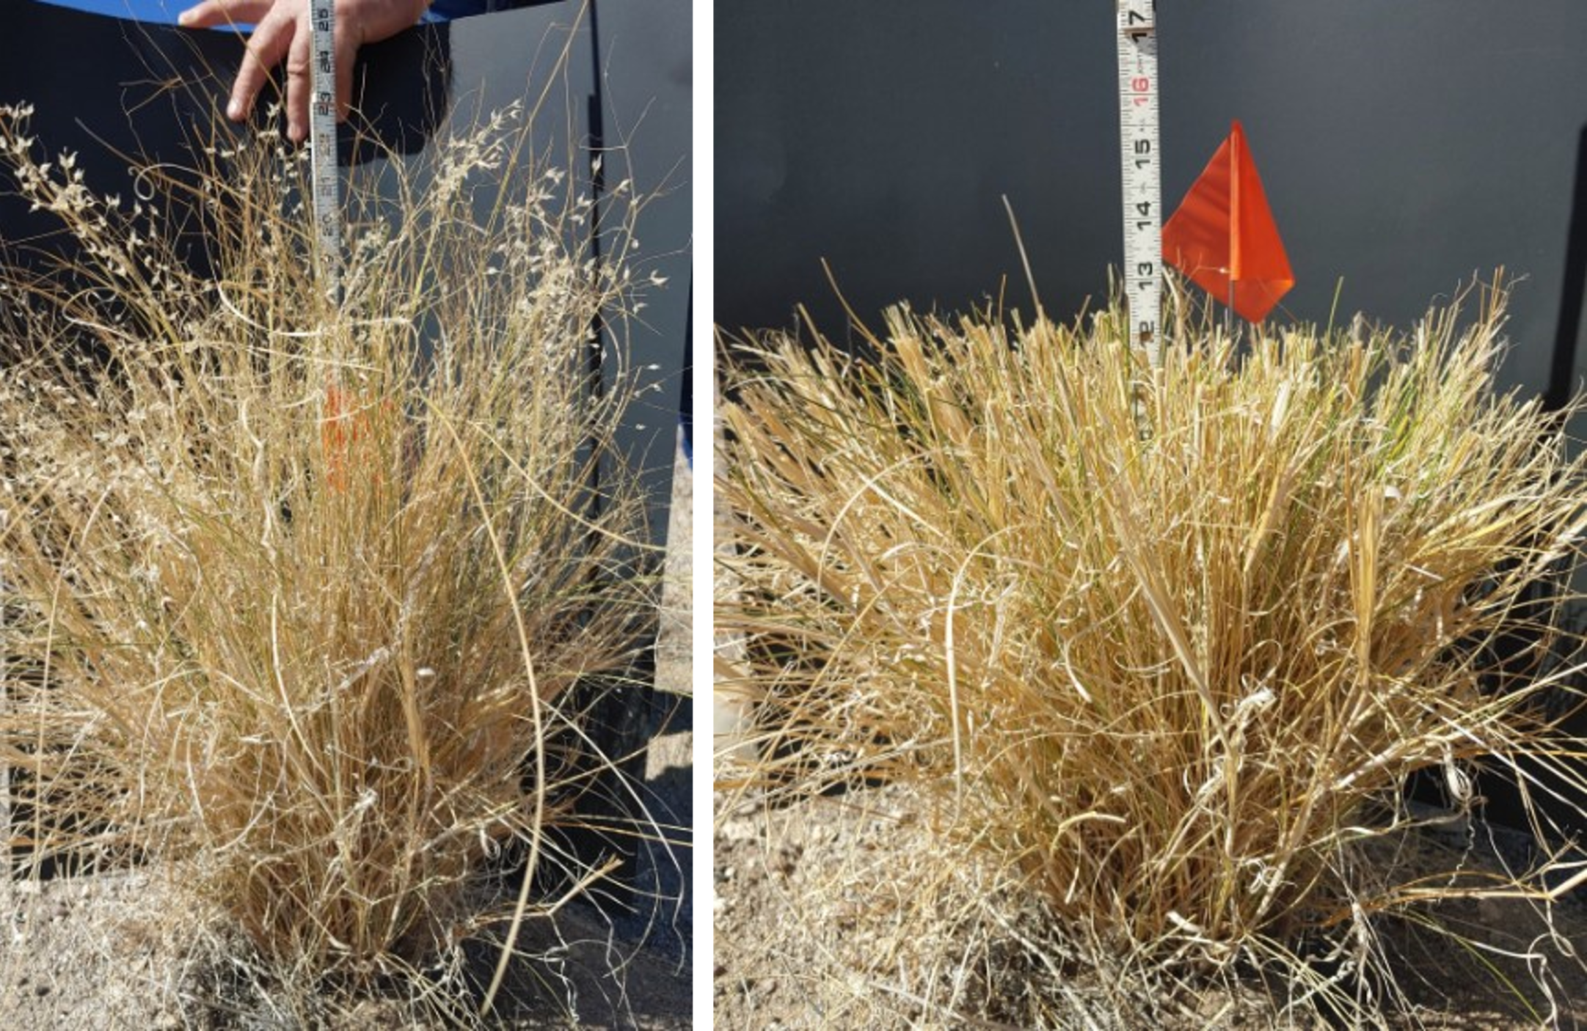
Part 5B: Shrub Cover Estimates
Use the measuring tape to lay out a transect. Transect length will vary based on how many shrubs are on the site. Remember to keep it short enough to assure students will complete it in the time allotted plus all the other parts of this section (~20 minutes). Record transect length will be depicted on the placard. Each participant will examine the transect and measure the canopy cover of sagebrush that intercepts the transect. Measurements will be completed for sagebrush only. Gaps of <2.5 inches (green to green) are disregarded.
